Spring MVC入门Demo

1 建立一个名为springmvcdemo的Maven Project，具体步骤见

<http://blog.csdn.net/haishu_zheng/article/details/51490299>

2 文件目录结构如下图所示

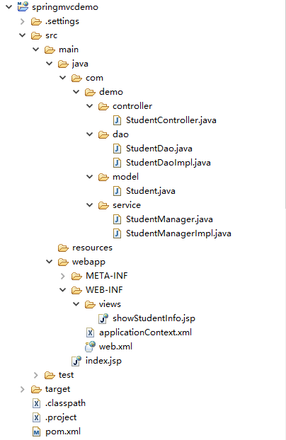

3 在pom.xml中添加

<dependency>

<groupId>org.springframework</groupId>

<artifactId>spring-web</artifactId>

<version>3.2.9.RELEASE</version>

</dependency>

<dependency>

<groupId>org.springframework</groupId>

<artifactId>spring-webmvc</artifactId>

<version>3.2.9.RELEASE</version>

</dependency>

4 web.xml中的完整内容为

<?xml version=*"1.0"* encoding=*"UTF-8"*?>

<web-app xmlns:xsi=*"http://www.w3.org/2001/XMLSchema-instance"*

xmlns=*"http://xmlns.jcp.org/xml/ns/javaee"*

xsi:schemaLocation=*"http://xmlns.jcp.org/xml/ns/javaee http://xmlns.jcp.org/xml/ns/javaee/web-app_3_1.xsd"*

id=*"WebApp_ID"* version=*"3.1"*>

<display-name>springmvcdemo</display-name>

<servlet>

<servlet-name>spring</servlet-name>

<servlet-class>org.springframework.web.servlet.DispatcherServlet</servlet-class>

<init-param>

<param-name>contextConfigLocation</param-name>

<param-value>/WEB-INF/applicationContext.xml</param-value>

</init-param>

<load-on-startup>1</load-on-startup>

</servlet>

<servlet-mapping>

<servlet-name>spring</servlet-name>

<url-pattern>/</url-pattern>

</servlet-mapping>

</web-app>

5 applicationContext.xml中的完整内容为：

<beans xmlns=*"http://www.springframework.org/schema/beans"*

xmlns:xsi=*"http://www.w3.org/2001/XMLSchema-instance"*

xmlns:context=*"http://www.springframework.org/schema/context"*

xsi:schemaLocation=*"http://www.springframework.org/schema/beans*

*http://www.springframework.org/schema/beans/spring-beans-3.0.xsd*

*http://www.springframework.org/schema/context*

*http://www.springframework.org/schema/context/spring-context-3.0.xsd"*>

<context:component-scan base-package=*"com.demo"* />

<bean class=*"org.springframework.web.servlet.mvc.annotation.DefaultAnnotationHandlerMapping"* />

<bean class=*"org.springframework.web.servlet.mvc.annotation.AnnotationMethodHandlerAdapter"* />

<bean class=*"org.springframework.web.servlet.view.InternalResourceViewResolver"*>

<property name=*"prefix"* value=*"/WEB-INF/views/"* />

<property name=*"suffix"* value=*".jsp"* />

</bean>

</beans>

6 Student.java中的完整代码为

**package** com.demo.model;

**import** java.io.Serializable;

**public** **class** Student **implements** Serializable {

**private** **static** **final** **long** *serialVersionUID* = 1L;

**private** Integer id;

**private** String name;

**public** Integer getId() {

**return** id;

}

**public** **void** setId(Integer id) {

**this**.id = id;

}

**public** String getName() {

**return** name;

}

**public** **void** setName(String name) {

**this**.name = name;

}

@Override

**public** String toString() {

**return** "Student [id=" + id + ", name=" + name + "]";

}

}

7 StudentDao.java中的完整代码为

**package** com.demo.dao;

**import** java.util.List;

**import** com.demo.model.Student;

**public** **interface** StudentDao {

**public** List<Student> getAllStudents();

}

8 StudentDaoImpl.java中的完整代码为

**package** com.demo.dao;

**import** java.util.ArrayList;

**import** java.util.List;

**import** org.springframework.stereotype.Repository;

**import** com.demo.model.Student;

@Repository

**public** **class** StudentDaoImpl **implements** StudentDao {

**public** List<Student> getAllStudents() {

List<Student> students = **new** ArrayList<Student>();

Student stu1 = **new** Student();

stu1.setId(1);

stu1.setName("Zhang San");

students.add(stu1);

Student stu2 = **new** Student();

stu2.setId(2);

stu2.setName("Li Si");

students.add(stu2);

**return** students;

}

}

9 StudentManager.java中的完整代码为：

**package** com.demo.service;

**import** java.util.List;

**import** com.demo.model.Student;

**public** **interface** StudentManager {

**public** List<Student> getAllStudents();

}

10 StudentManagerImpl.java中的完整代码为：

**package** com.demo.service;

**import** java.util.List;

**import** org.springframework.stereotype.Service;

**import** org.springframework.beans.factory.annotation.Autowired;

**import** com.demo.dao.StudentDao;

**import** com.demo.model.Student;

**import** com.demo.service.StudentManager;

@Service

**public** **class** StudentManagerImpl **implements** StudentManager {

@Autowired

StudentDao dao;

**public** List<Student> getAllStudents() {

**return** dao.getAllStudents();

}

}

11 StudentController.java中的完整代码为：

**package** com.demo.controller;

**import** org.springframework.beans.factory.annotation.Autowired;

**import** org.springframework.stereotype.Controller;

**import** org.springframework.web.bind.annotation.RequestMapping;

**import** org.springframework.web.bind.annotation.RequestMethod;

**import** org.springframework.ui.Model;

**import** com.demo.service.StudentManager;

**package** com.demo.controller;

**import** org.springframework.beans.factory.annotation.Autowired;

**import** org.springframework.stereotype.Controller;

**import** org.springframework.web.bind.annotation.RequestMapping;

**import** org.springframework.web.bind.annotation.RequestMethod;

**import** org.springframework.ui.Model;

**import** com.demo.service.StudentManager;

@Controller

@RequestMapping("/student-module")

**public** **class** StudentController {

@Autowired

StudentManager manager;

@RequestMapping(value = "/getStudentInfo", method = RequestMethod.*GET*)

**public** String getStudentInfo(Model model) {

model.addAttribute("students", manager.getAllStudents());

**return** "showStudentInfo";

}

}

12 showStudentInfo.jsp中的完整代码为：

<%@ taglib prefix=*"c"* uri=*"http://java.sun.com/jsp/jstl/core"*%>

<%@ taglib prefix=*"fmt"* uri=*"http://java.sun.com/jsp/jstl/fmt"*%>

<html>

<head>

<title>Spring MVC Demo</title>

</head>

<body>

<h2>All Students</h2>

<table border=*"1"*>

<tr>

<th>Student Id</th>

<th>Student Name</th>

</tr>

<c:forEach items=*"*${students}*"* var=*"student"*>

<tr>

<td>${student.id}</td>

<td>${student.name}</td>

</tr>

</c:forEach>

</table>

</body>

</html>

13 将springmvcdemo添加进Tomcat 7中并运行

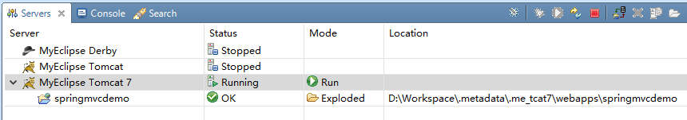

在浏览器中输入

<http://localhost:8080/springmvcdemo/student-module/getStudentInfo>

显示结果为

